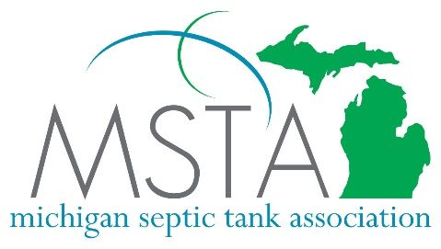
2024 MSTA Conference Registration Form
Soaring Eagle Resort, Mt. Pleasant MI February 12-14, 2024

USE THIS FORM FOR CHECK PAYMENT ONLY. OTHERWISE REGISTER ONLINE AT WWW.MSTA.BIZ
COMPANY NAME: _________________________________________________________________
ADDRESS: ________________________________________________________________________
CITY: ________________________________________ STATE: _______ ZIP: ___________
EMAIL ADDRESS: _________________________________ (required) PH # : _____________________ (required)
REGISTRATION FEES
Member price: (circle one) Hotel Information
$160 per person* before January 1 Call 877-232-4532. Mention Room
$190 per person* after January 1 Block Code MSTA021224 for a special
rate for Sunday night-Tuesday night
Non-Member price: (circle one)
$450 per person* before January 1
$480 per person* after January 1
I will be attending the following days:
Monday
Tuesday
Wednesday
* includes all meals and 1 banquet ticket for Annual Banquet on Tuesday night

Additional People attending from same company:
NAME: _____________________________________________ (circle) Mon, Tues, Wed. $________________
NAME: _____________________________________________ (circle) Mon, Tues, Wed. $________________
NAME: _____________________________________________ (circle) Mon, Tues, Wed. $________________
NAME: _____________________________________________ (circle) Mon, Tues, Wed. $________________
Each person registered gets 1 banquet ticket. If you would like additional banquet tickets for guests, enter the number of additional tickets you would like to purchase at $40 each.
Additional Tickets ______________ X $40 each $________________
TOTAL FEE $________________

Make check payable to: MSTA and send to 1181 LaCosta Drive DeWitt, MI 48820

